Project Design Phase
Problem – Solution Fit Template

Date | 24 February 2026
Team ID | LTVIP2026TMIDS42582
Project Name | Home-Rentals
Maximum Marks | 2 Marks

Problem–Solution Fit Template
Purpose:
- Solve complex problems in a way that fits the state of your customers.
- Succeed faster and increase your solution adoption by tapping into existing mediums and channels of behavior.
- Sharpen your communication and marketing strategy with the right triggers and messaging.
- Increase touch-points with your company by finding the right problem-behavior fit and building trust by solving frequent annoyances, or urgent or costly problems.
- Understand the existing situation in order to improve it for your target group.

1. Customer Segment(s):
- Urban professionals, families, and students seeking short-term or long-term rental properties.
- Property owners/hosts looking to list and manage their rentals.
2. Jobs-to-be-done / Problems:
- Customers need a reliable way to find, compare, and book rental properties.
- Hosts need an easy platform to list properties, manage bookings, and communicate with guests.
- Both parties want secure payment and transparent processes.
3. Triggers:
- Moving to a new city for work or study.
- Need for temporary accommodation during travel.
- Dissatisfaction with current rental search platforms.
4. Emotions: Before / After:
- Before: Frustration, uncertainty, lack of trust, time-consuming search.
- After: Relief, confidence, satisfaction, trust in the platform.
5. Available Solutions:
- Traditional real estate agents.
- Classifieds websites.
- Competing rental platforms (Airbnb, Booking.com).
6. Customer Constraints:
- Limited budget.
- Need for verified listings and secure payments.
- Desire for quick booking and responsive support.
7. Behaviour:
- Customers browse listings online, compare options, read reviews, and contact hosts.
- Hosts monitor inquiries, update availability, and respond to messages

Template:
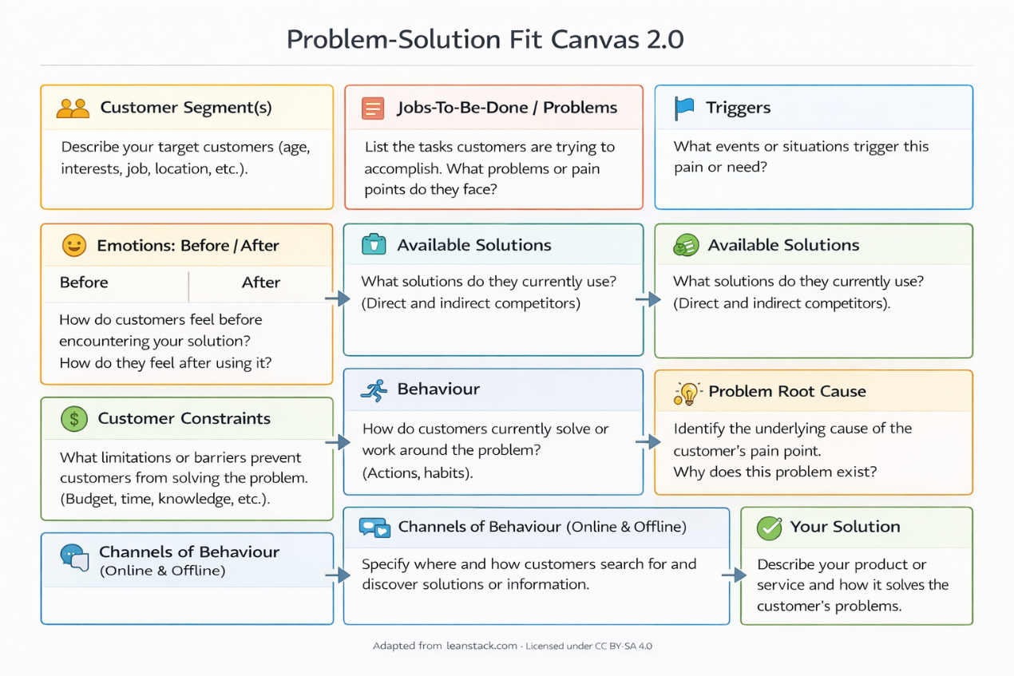
References:
- https://www.ideahackers.network/problem-solution-fit-canvas/
- https://medium.com/@epicantus/problem-solution-fit-canvas-aa3dd59cb4fe

